Justin Feistner

0910863

SWDV 665 – Advanced Something Rather

10/30/2019

**Pocket Pets**

(Final App Project Write-up)

**Overview**

The Pocket Pets app is designed to let pet enthusiasts photograph their pets. That image is then saved to a gallery where the user can later look at the image and make specific notes about an image. This way the user will always be able to cherish their favorite photos of their pet and know exactly what they were doing at that time.

**Wireframe**

Below are the different pages the user will be able to access when they install the app on their phone. Briefly, those pages are Camera Screen, Pictures Screen, and Picture Details. See below:

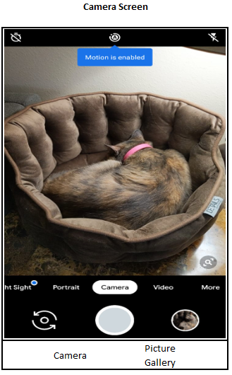

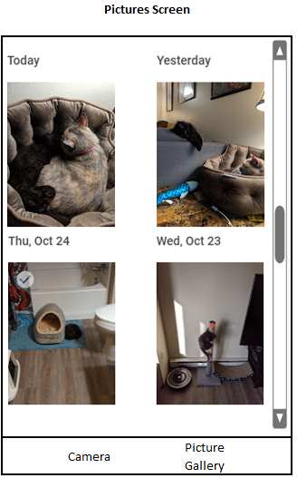

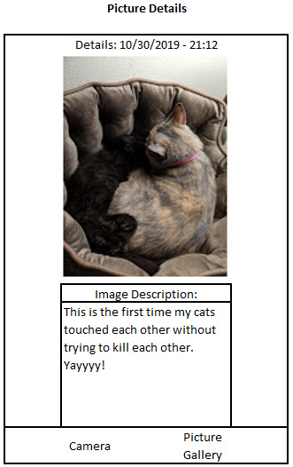

**Implementation**

The application will likely require the use of a database to record specific information about an image. That, or the details about an image will be stored locally on the device. The application has access to the device’s camera which is enabled through Cordova.